Heuristic Evaluation On Micro-Blogging Platforms

German University on Cairo

Supervisor: Dr. Wael

By:

Ahmed Hesham

Heuristic evaluation, is a technique developed originally in 1990 by Rolf Molich and Jakob Nielsen, before being improved in 1994 by Nielsen, to help locate usability problems, in user interface design. This technique however, is not a to be used as a replacement for usability testing, in which the interface is tested on actual users.   
Microblogging platforms are a new trend in the internet, where they are a hybrid of both blogging and instant messaging that enable users to post short messages in the form of a status, they are mostly used for promotions of products. The most renowned platform is Twitter.

Heuristic evaluation allocates 10 different assessors, to rate the interface according to predefined heuristics. Which are:

1. Visibility of system status - the system should provide appropriate feedback to users happening within a certain frame of time.
2. Match between system and real world - the system should be presented in the target user’s language and terminology and present information in logical order.
3. User control and freedom - the system should handle if a user should perform an unwanted function to roll back or reapply said operation, furthermore it should allow the user to opt out of an operation with a clearly marked exit button.
4. Consistency and standards - the system should not present ambiguous operations to the user; platform conventions should be applied.
5. Error prevention - error prone conditions should not exist or request user confirmation before they perform an error prone action.
6. Recognition than recall - users are not required to memorize the locations of items in the interface, they should be presented clearly, nor is the user required to remember information from one dialogue to another.
7. Flexibility and efficiency - system should cater to both experienced and inexperienced users by tailoring specific actions to each, for example accelerators are faster for experienced users.
8. Aesthetic and minimalist design - dialogues should only contain relevant information, any extra unneeded information reduces the visibility of required information.
9. Help users recognize, diagnose and recover from errors - error messages should be expressed in plain language (i.e. no advanced terminology), pinpoint the problem and suggest a valid solution.
10. Help and documentation - help and documentation should be available to the user, with tools for easy retrieval of information.

- Twitter

Launched in 2006 by Jack Dorsey. Over the years Twitter has had numerous make overs. This is current display of the timeline (Some data has been hidden for discretion):

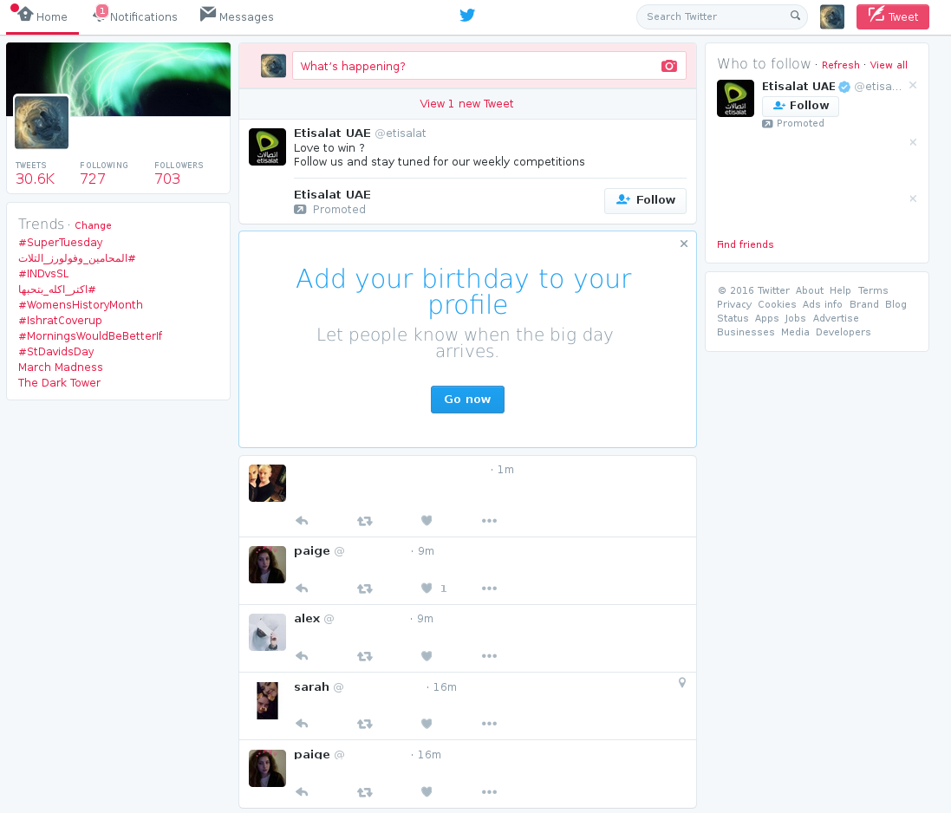

Applying the heuristics above:

1. Visibility of system status: from the interface we can see that there is constant update of the timeline for new tweets which occurs every couple of minutes and the feedback is through the box under the tweet creation, thus grabbing the user’s attention.
2. Match between system and real world: the interface uses simple terminologies, with the exception of the word tweet, which is an alias for post. Also the system uses simple icons to perform operations such as reply, retweet and favorite, the three dots indicate more options.  
     
   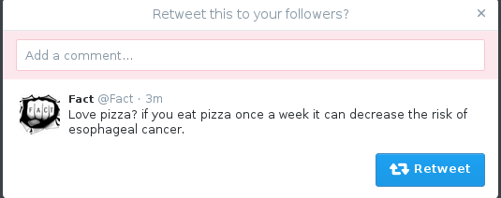
3. User control and freedom: when a user clicks a retweet button, they are faced with this box, there is a close button should the user opt out, however it is not big enough a cancel button would be better. Should a user still retweet and like to undo the effect, they need to navigate to their profile and click the retweet button for it turn grey indicating an undo, there is no undo button. Similarly for the “fav” button. For a deletion of a tweet the user again has to find it on their profile and choose extra options on the tweet and delete it, there is no quick access button.

Screenshot from 2016-03-01 20-40-37

Screenshot from 2016-03-01 20-23-59

1. Consistency and standards: over the years the favorite button has been replaced from a star to a heart with no notification to inform the user.  
     
   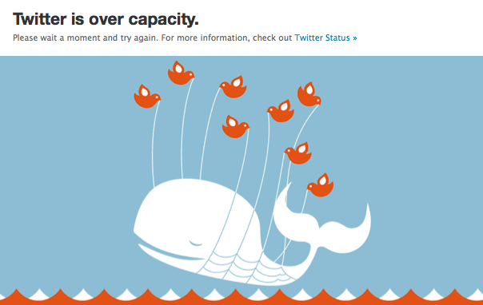
2. Error prevention: prior to the switch from ruby on rails to scala in 2011, twitter often faced overloads and the above error was displayed, and the user was forced to wait until the load went down. After the switch the error is no longer displayed, however occasionally the user is prompted with an unknown error (picture not attached as it occurs rarely) and asks the user to refresh the page.

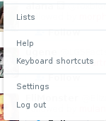

1. Recognition rather than recall: generally everything in the interface is laid out for easy reach infront of the user except for the delete tweet option and lists page, this has to be accessed from profile menu shown above.
2. Flexibility and efficiency: twitter offers keyboard shortcuts for advanced users in the profile menu shown above.
3. Aesthetic and minimalist design: twitter has been changing its design over the years to keep up with the trends of design, as of 2014 it started shifting towards minimalistic design with the overall theme being more flat. Dialogues have been to the point without extra information, with the exception of friend suggestions which offers “friends” being promoted due to advertisements.

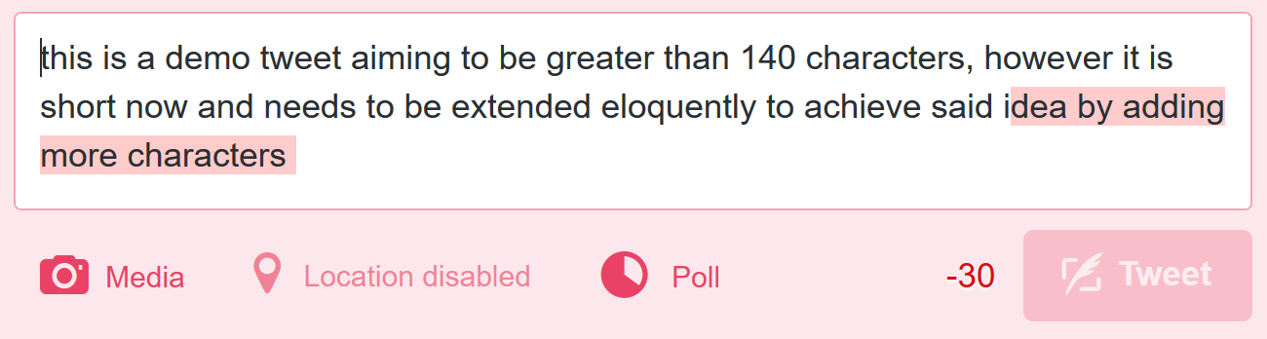

1. Help users recognize, diagnose, and recover from errors: twitter follows these guidelines; when a user for example creates a tweet with more than 140 character, the extra characters are highlighted with red and the tweet button is disabled. However, occasionally a random error occurs (no picture attached) that does not explain the problem and simple asks user to refresh the page.

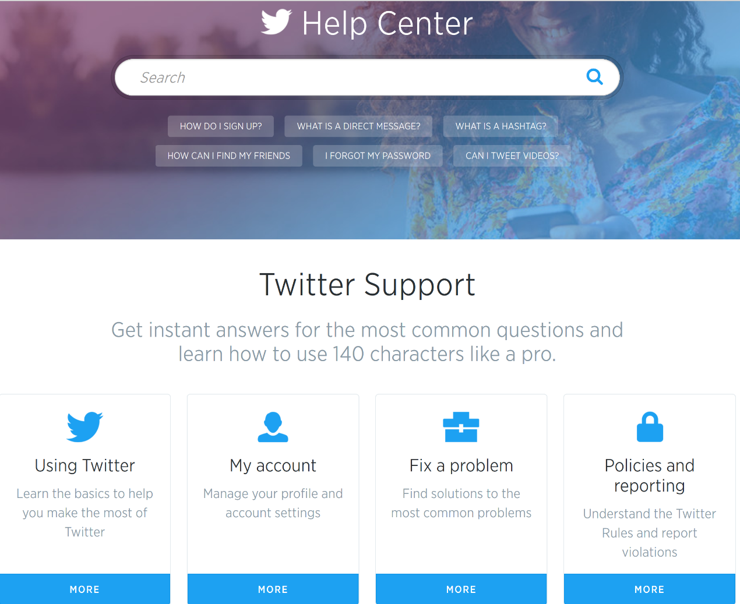

1. Help and documentation: twitter features a help center for those new to twitter, though it is location can be obscure for new users as it is placed in the profile menu.

-Tumblr

Another microblogging platform founded by David Karp in 2007. Similar to twitter, it offers the users to upload pictures and videos and to create posts but without the limitation on text size.

The landing page after logging in (named “Dashboard”)

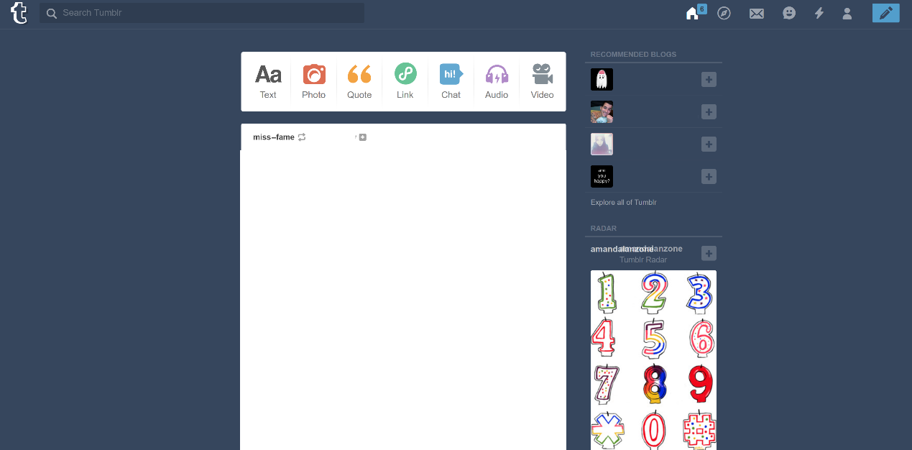

1. Visibility of system status: unlike twitter, the site does not automatically refresh the page to get new posts because the site is page based while twitter is not; twitter allows the user to back in time infinitely till the first tweet the user tweeted. To get new posts, the user has to refresh tumblr or click on the home button which shows how many new posts have arrived so far.
2. Match between system and real world: the site uses simple terminologies to attract the user

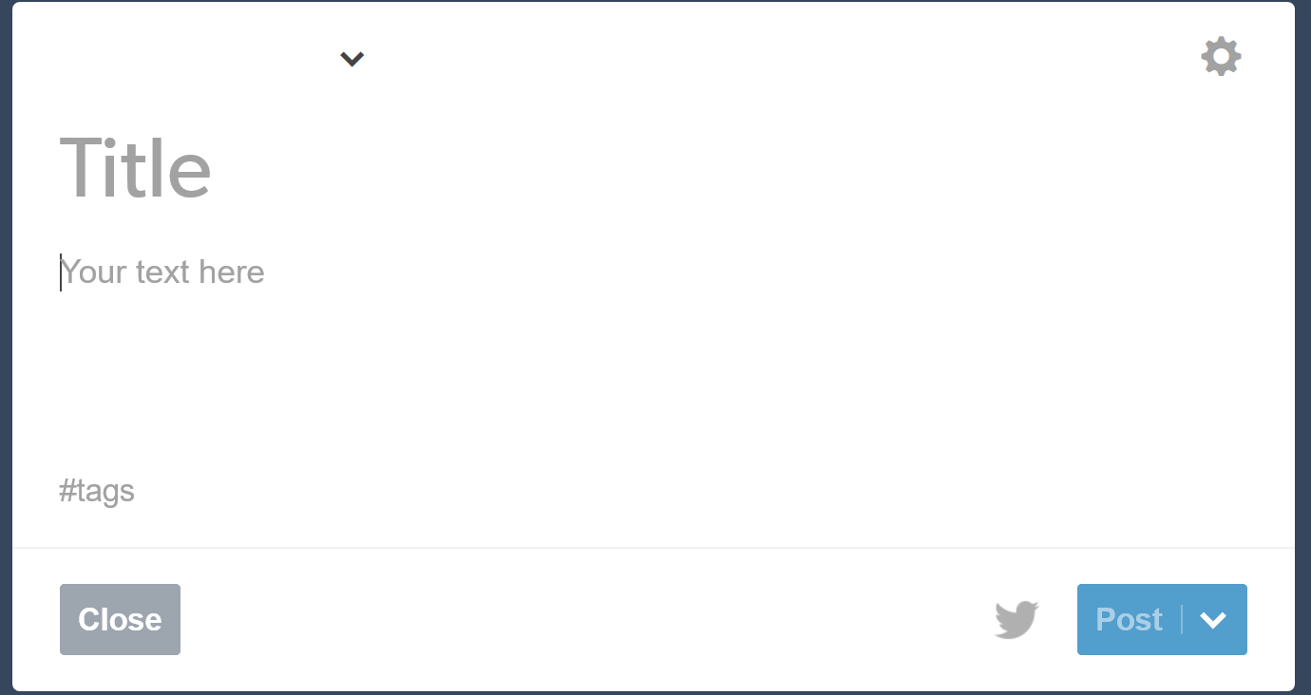

1. User control and freedom: unlike twitter, tumblr features a clear close button should a user not want to create a post. However there are no undos for post creation, the user should navigate to their profile and delete the post manually but, the advanced user can undo a reblog using a special shortcut. All users can undo a like by pressing the heart again.
2. Consistency and standards: there arises some ambiguity between text, link, and quote users must try them out to see the difference. Furthermore there is also an ambiguity between chat and messages.
3. Error prevention: tumblr has mostly eliminated error prone conditions to provide a consistent experience
4. Recognition rather than recall: tumblr heavily relies on icons than text for the user to use its functions, the user may at first need to use them for a while to get used to them
5. Flexibitliy and efficiency of use: tumblr caters for advanced users by providing shortcuts for advanced users however they are not documented and are discovered by users.
6. Aesthetic and minimalist design: over the years tumblr has shifted to minimalistic design, if a user has linked their twitter account on tumblr and button to tweet appears.
7. Help users recognize, diagnose, and recover from errors: banned accounts are simply removed from the system and the link to the account is not removed but maps to an error page, the user does not know if the account is banned or not.

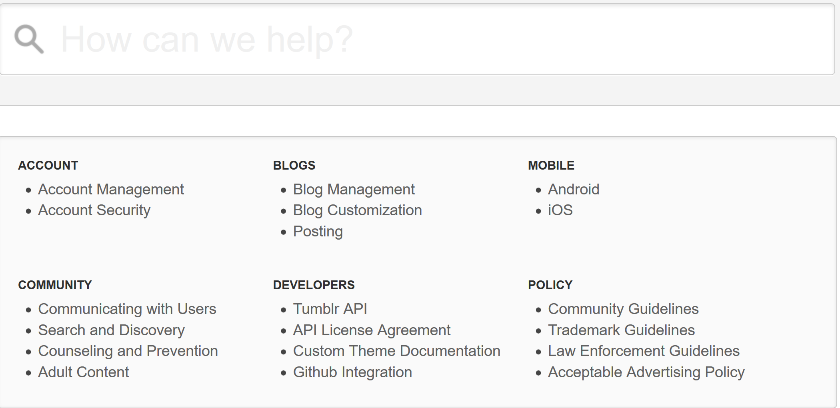

1. Help and documentation: tumblr offers a help center as well.

References:

<http://webtrends.about.com/od/glossary/g/micro-blogging.htm>

<https://www.nngroup.com/topic/heuristic-evaluation/>

http://www.usability.gov/how-to-and-tools/methods/heuristic-evaluation.html